JavaScript Assignment #2

**Part 1: What’s Your GPA**

[Paste your part 1 Code below]

<!doctype html>

<html>

<head>

<title>Frank Pedraza A2P1</title>

</head>

<body style="background-color:navajowhite;">

<h1>Frank Pedraza A2P1</h1>

<script language="JavaScript" type="text/javascript">

<!--

var first = prompt("Please enter your first name: ");

var gpa = prompt("Please enter your GPA, "+first);

gpa = parseFloat(gpa);

if (gpa < 1.0)

{

document.write('<p>'+first+', your GPA of '+gpa.toFixed(2)+' results in an F grade.</p>');

}

else if (gpa >= 1.0 && gpa < 2.0)

{

document.write('<p>'+first+', your GPA of '+gpa.toFixed(2)+' results in a D grade.</p>');

}

else if (gpa >= 2.0 && gpa < 3.0)

{

document.write('<p>'+first+', your GPA of '+gpa.toFixed(2)+' results in a C grade.</p>');

}

else if (gpa >= 3.0 && gpa < 4.0)

{

document.write('<p>'+first+', your GPA of '+gpa.toFixed(2)+' results in a B grade.</p>');

}

else if (gpa >= 4.0 && gpa<=5.0)

{

document.write('<p>'+first+', your GPA of '+gpa.toFixed(2)+' results in an A grade.</p>');

}

else {

document.write('<p>Please enter a valid GPA.</p>');

}

//-->

</script>

</body>

</html>

**Part 2: Gimme Some Products**

[Paste your part 2 screen shot below]

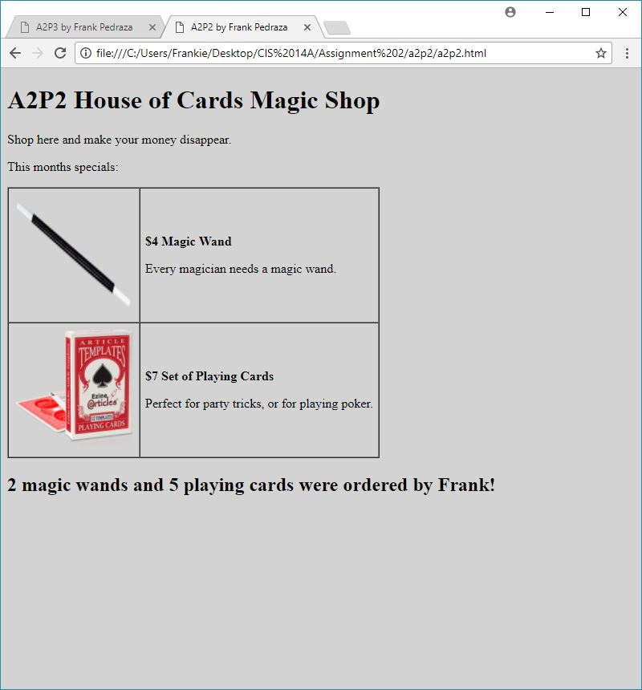

[Paste your part 2 Code below]

<!doctype html>

<html>

<head>

<meta charset="utf-8">

<title>A2P2 by Frank Pedraza</title>

</head>

<body style="background-color: lightgrey">

<h1>A2P2 House of Cards Magic Shop</h1>

<p>Shop here and make your money disappear.</p>

<p>This months specials:</p>

<table border="1" cellspacing="0" cellpadding="6" summary="Table of product images and prices and descriptions">

<tbody>

<tr>

<td><img src="magic_wand.png" alt="Magic Wand" height="150" width="150"></td>

<td><p style="font-weight: bold">$4 Magic Wand</p>

<p>Every magician needs a magic wand.</p></td>

</tr>

<tr>

<td><img src="cards.png" alt="Playing Cards" height="150" width="150"></td>

<td><p style="font-weight: bold">$7 Set of Playing Cards</p>

<p>Perfect for party tricks, or for playing poker.</p></td>

</tr>

</tbody>

</table>

<script>

var FirstName = prompt('Welcome to House of Cards Magic Shop. Please enter your name.');

var numWand = prompt(FirstName+', How many magic wands would you like to purchase today?');

var numCards = prompt(FirstName+', How many sets of playing cards would you like to purchase today?');

document.write('<h2>'+numWand+' magic wands and '+numCards+' playing cards were ordered by '+FirstName+'!</h2');

</script>

</body>

</html>

**Part 3: Receipt This!**

[Page Your part 3 Screenshot below]

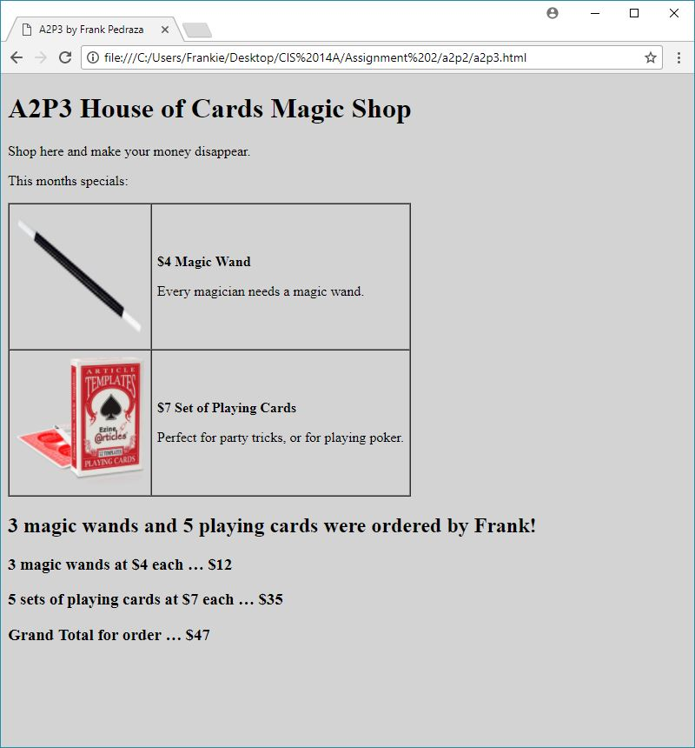

[Paste your part 3 Code Below your screen shot]

<!doctype html>

<html>

<head>

<meta charset="utf-8">

<title>A2P3 by Frank Pedraza</title>

</head>

<body style="background-color: lightgrey">

<h1>A2P3 House of Cards Magic Shop</h1>

<p>Shop here and make your money disappear.</p>

<p>This months specials:</p>

<table border="1" cellspacing="0" cellpadding="6" summary="Table of product images and prices and descriptions">

<tbody>

<tr>

<td><img src="magic_wand.png" alt="Magic Wand" height="150" width="150"></td>

<td><p style="font-weight: bold">$4 Magic Wand</p>

<p>Every magician needs a magic wand.</p></td>

</tr>

<tr>

<td><img src="cards.png" alt="Playing Cards" height="150" width="150"></td>

<td><p style="font-weight: bold">$7 Set of Playing Cards</p>

<p>Perfect for party tricks, or for playing poker.</p></td>

</tr>

</tbody>

</table>

<script>

var FirstName = prompt('Welcome to House of Cards Magic Shop. Please enter your name.');

var numWand = prompt(FirstName+', How many magic wands would you like to purchase today?');

var numCards = prompt(FirstName+', How many sets of playing cards would you like to purchase today?');

document.write('<h2>'+numWand+' magic wands and '+numCards+' playing cards were ordered by '+FirstName+'!</h2<br>');

var totalWand = numWand*4;

var totalCards = numCards*7;

var subTotal = totalCards+totalWand;

document.write('<h3>'+numWand+' magic wands at $4 each … $'+totalWand);

document.write('<h3>'+numCards+' sets of playing cards at $7 each … $'+totalCards);

document.write('<h3>Grand Total for order … $'+subTotal+'<h3>');

</script>

</body>

</html>

**Part 4: If it Don’t Make Dollar$, it Don’t Make ¢ents!**

[Page Your part 4 Screenshot below]

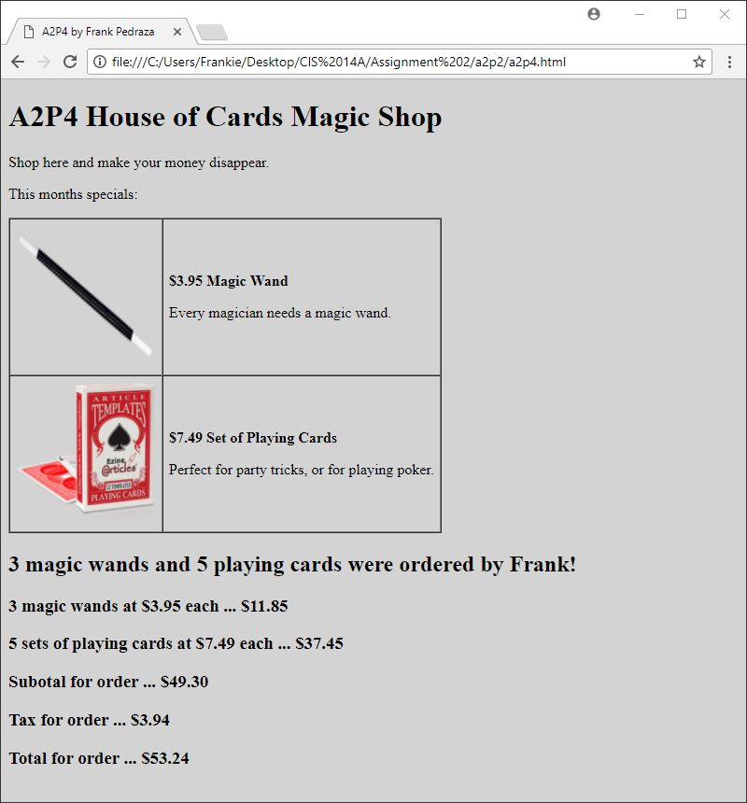

[Paste your part 4 Code Below your screen shot]

<!doctype html>

<html>

<head>

<meta charset="utf-8">

<title>A2P4 by Frank Pedraza</title>

</head>

<body style="background-color: lightgrey">

<h1>A2P4 House of Cards Magic Shop</h1>

<p>Shop here and make your money disappear.</p>

<p>This months specials:</p>

<table border="1" cellspacing="0" cellpadding="6" summary="Table of product images and prices and descriptions">

<tbody>

<tr>

<td><img src="magic_wand.png" alt="Magic Wand" height="150" width="150"></td>

<td><p style="font-weight: bold">$3.95 Magic Wand</p>

<p>Every magician needs a magic wand.</p></td>

</tr>

<tr>

<td><img src="cards.png" alt="Playing Cards" height="150" width="150"></td>

<td><p style="font-weight: bold">$7.49 Set of Playing Cards</p>

<p>Perfect for party tricks, or for playing poker.</p></td>

</tr>

</tbody>

</table>

<script>

var FirstName = prompt('Welcome to House of Cards Magic Shop. Please enter your name.');

var numWand = prompt(FirstName+', How many magic wands would you like to purchase today?');

var numCards = prompt(FirstName+', How many sets of playing cards would you like to purchase today?');

document.write('<h2>'+numWand+' magic wands and '+numCards+' playing cards were ordered by '+FirstName+'!</h2<br>');

var totalWand = numWand*3.95;

var totalCards = numCards*7.49;

var subTotal = totalCards+totalWand;

var tax = subTotal*0.08;

var total = subTotal+tax;

document.write('<h3>'+numWand+' magic wands at $3.95 each ... $'+totalWand.toFixed(2));

document.write('<h3>'+numCards+' sets of playing cards at $7.49 each ... $'+totalCards.toFixed(2));

document.write('<h3>Subotal for order ... $'+subTotal.toFixed(2)+'<h3>');

document.write('<h3>Tax for order ... $'+tax.toFixed(2)+'<h3>');

document.write('<h3>Total for order ... $'+total.toFixed(2)+'<h3>');

</script>

</body>

</html>

**Part 5: What The Function?**

[Paste your part 5 Code Below]

<!doctype html>

<html>

<head>

<meta charset="utf-8">

<title>A2P5 by Frank Pedraza</title>

<script>

function receipt(){

document.write('<h2>'+numWand+' magic wands and '+numCards+' playing cards were ordered by '+FirstName+'!</h2<br>');

var totalWand = numWand*3.95;

var totalCards = numCards*7.49;

var subTotal = totalCards+totalWand;

var tax = subTotal*0.08;

var total = subTotal+tax;

document.write('<h3>'+numWand+' magic wands at $3.95 each ... $'+totalWand.toFixed(2));

document.write('<h3>'+numCards+' sets of playing cards at $7.49 each ... $'+totalCards.toFixed(2));

document.write('<h3>Subotal for order ... $'+subTotal.toFixed(2)+'<h3>');

document.write('<h3>Tax for order ... $'+tax.toFixed(2)+'<h3>');

document.write('<h3>Total for order ... $'+total.toFixed(2)+'<h3>');

}

</script>

</head>

<body style="background-color: lightgrey">

<h1>A2P5 House of Cards Magic Shop</h1>

<p>Shop here and make your money disappear.</p>

<p>This months specials:</p>

<table border="1" cellspacing="0" cellpadding="6" summary="Table of product images and prices and descriptions">

<tbody>

<tr>

<td><img src="magic_wand.png" alt="Magic Wand" height="150" width="150"></td>

<td><p style="font-weight: bold">$3.95 Magic Wand</p>

<p>Every magician needs a magic wand.</p></td>

</tr>

<tr>

<td><img src="cards.png" alt="Playing Cards" height="150" width="150"></td>

<td><p style="font-weight: bold">$7.49 Set of Playing Cards</p>

<p>Perfect for party tricks, or for playing poker.</p></td>

</tr>

</tbody>

</table>

<script>

var FirstName = prompt('Welcome to House of Cards Magic Shop. Please enter your name.');

var numWand = prompt(FirstName+', How many magic wands would you like to purchase today?');

var numCards = prompt(FirstName+', How many sets of playing cards would you like to purchase today?');

receipt();

</script>

</body>

</html>